**2014 Honda Accord Longitudinal Control**

**MAKE SURE PANDA IS PLUGED IN AND POWERED ON BEFORE SWITCHING THE CAR ON!**

**Acceleration:**

* Accelerator pedal override with CAN control command
  + Make sure the switch on the pedal override box is switched to “ON” and the E-Stop button is released (twist counter-clockwise to release).
  + Connect CAN communication device to the DB-9 connector of the pedal override box (labeled “ACCEL OVERRIDE”),
  + No termination resistor necessary.
  + Must initially send control message with a raw value = 0 to enable override control.
  + Use CAN control message to command accelerator pedal position within the range of 0 to 100%
  + CAN control Message:
    - CAN Type: Std 11 bit
    - Arb ID: 098
    - Length: 1 byte
    - Acceleration control signal:
      * Byte 1
      * Scaling: {Raw Value}* 0.46698 - 3.74
      * Units: %

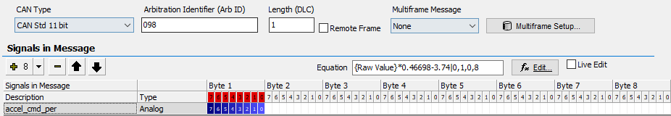

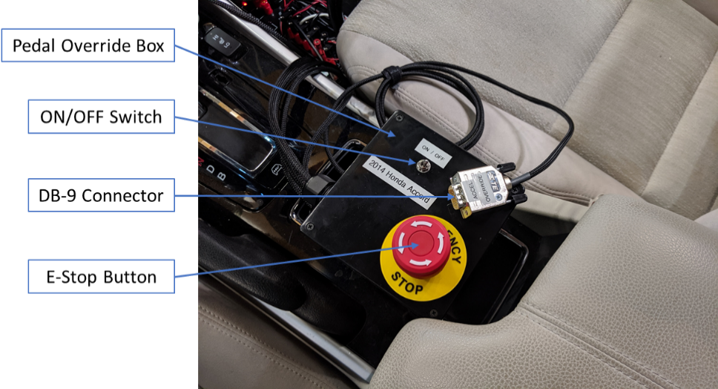

Figure 1: Pedal override box.

**Deceleration:**

* Brake override via man-in-the-middle control with Panda
  + Panda device must be plugged in and powered on before switching the car on
    - Powered on by releasing E-Stop button on Pedal override box
  + Panda MiM box must be connected to the pedal override E-Stop 2-pin connector to enable power to the Panda
  + Connect CAN communication device to the DB-9 connector of the Panda MiM box (labeled “BRAKE OVERRIDE”),
  + No termination resistor necessary.
  + Use CAN control message to command braking force within the range of 0 to 100%
  + CAN control message:
    - CAN Type: Std 11 bit
    - Arb ID: 099
    - Length: 6 byte
    - Brake Control Signal:
      * Byte 3
      * Scaling: {Raw Value}*0.392157
      * Units: %
    - Bytes 1, 2, 4, 5, and 6 should be set to 0

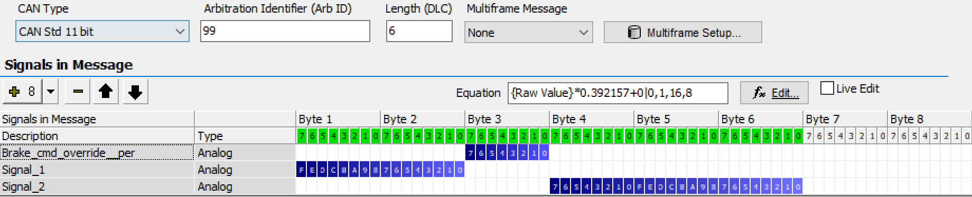

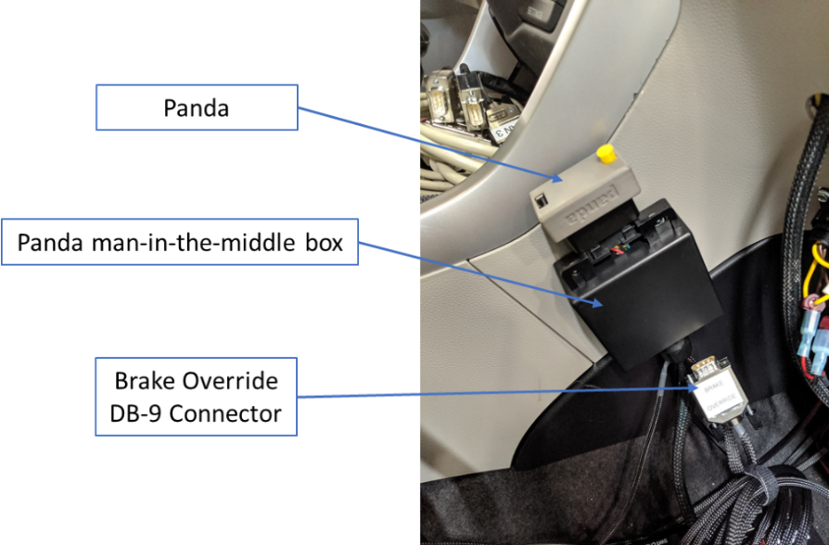

Figure 2: Panda man-in-the-middle box.

**Troubleshooting:**

|  |  |
| --- | --- |
| **Problem** | **Solution** |
| Stock accelerator pedal does not work | * Check that the E-Stop button on the pedal override box is released and re-start the car * Check pedal override box connection to accelerator pedal in driver foot compartment * Remove pedal override box connections from accelerator pedal and connect pedal by itself * Clear fault codes from the car * Restart car after attempting any of the solutions and re-try |
| Accelerator pedal override does not work | * Check that the switch on the pedal override box is switched to the “ON” position * Must send a CAN command signal equal to zero to initialize pedal override control every time the car or the pedal override box is first turned on. * Check that control message has length of 1 and Arb ID: 098 |
| Brake override does not work | * Check that the Panda is turned on   + 2-Pin Deutsch connector must be plugged in to pedal override box “E-Stop” connector and E-Stop should be released * CAN control message must have Arb ID: 099 * CAN control message must be 6 bytes long and control signal should be within byte 3 of the message   + All other bytes set to 0 |

**E-Stop Info:**

* Must be released before the car is turned on
  + Turns on stock accelerator pedal and pedal override box
  + Turns on power to Panda man-in-the-middle override box
* E-Stop button disables:
  + Stock accelerator pedal operation
  + Accelerator pedal override control
  + Panda man-in-the-middle override of braking
* Use only for emergency in case of longitudinal controller failure / unexpected behavior
* Can be used to switch off other equipment through the extra “E-Stop” connector
  + Creates open circuit between the two pins of the “E-Stop” connector when pressed

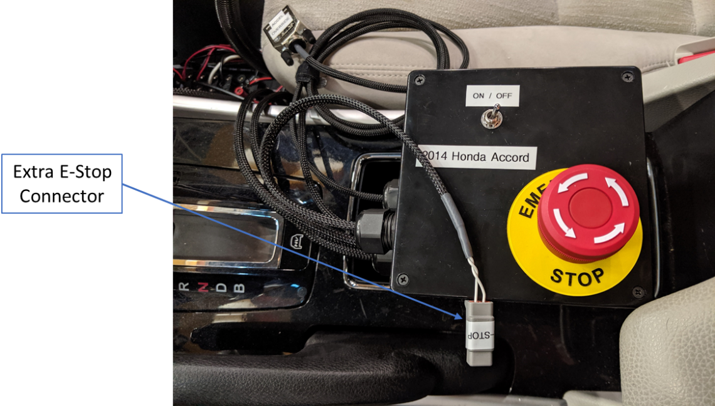

Figure 3: Pedal override box with extra e-stop connector.